**Class Project 2- Clustering & Classification**

Introduction to Big Data & Analytics

CSCI 6444

Group 13- Amish Raj, Arham Ashfaq  
Submitted to Professor Stephen Kaisler

**1. Dataset Description**

The data set is **abalone.data**, **abalone.names**. It is multivariate with 8 attributes and 4177 instances. Instances with missing values were removed, and the ranges of the continuous values were scaled for use with an ANN.

**Attribute information:**

Name / Data Type / Measurement Unit / Description

-----------------------------

Sex / nominal / -- / M, F, and I (infant)

Length / continuous / mm / Longest shell measurement

Diameter / continuous / mm / perpendicular to length

Height / continuous / mm / with meat in shell

Whole weight / continuous / grams / whole abalone

Shucked weight / continuous / grams / weight of meat

Viscera weight / continuous / grams / gut weight (after bleeding)

Shell weight / continuous / grams / after being dried

Rings / integer / -- / +1.5 gives the age in years.

**2. Objective**

The project aims to predict and determine the age of each abalone specimen based on the number of rings as a proxy. The age of abalone is determined by cutting the shell through the cone, staining it and then counting the number of rings through a microscope, which is why we will be predicting the number of rings for our project as a proxy for the age of each abalone specimen.

**3. Preparing the data and performing pairwise plotting**

We start by importing our dataset using the **read.table** method and using the comma sign “,” as a separator, into the **abal** variable.

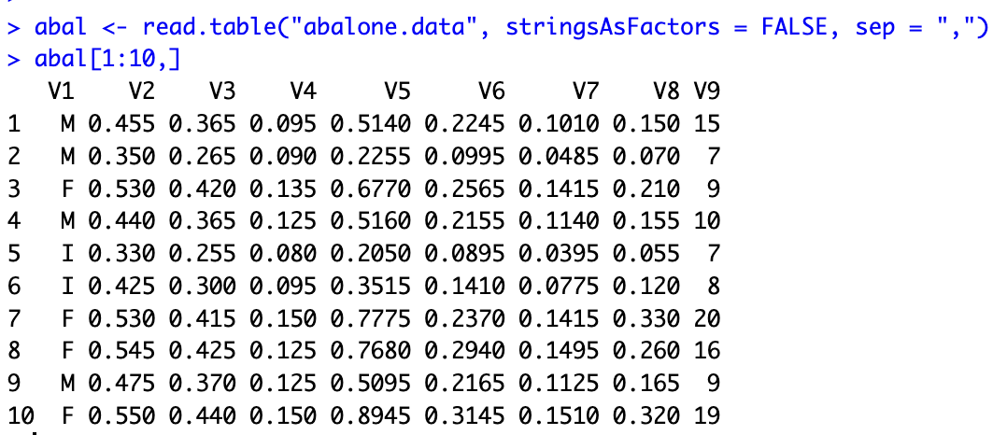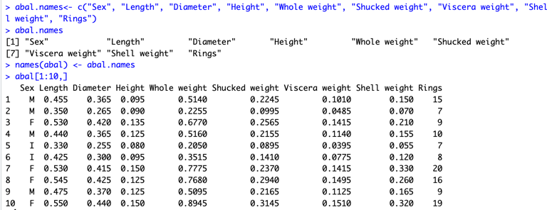

We then proceed to assign the names of the columns with columns in the dataframe as per the attribute information mentioned in the dataset description. Now that our data is structured in an understandable format, we can proceed to import the following libraries which will prove useful for our analysis: “**sna**”, “**psych**”, “**factoextra**”, “**plotly**”, “**ggplot2**”, “**corrplot**”, **“class”** and “**lattice**”.

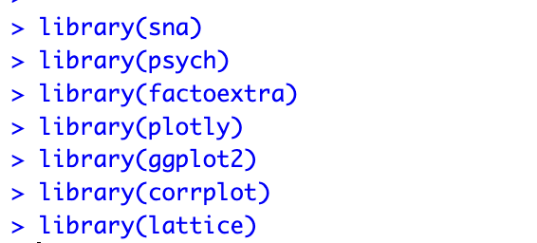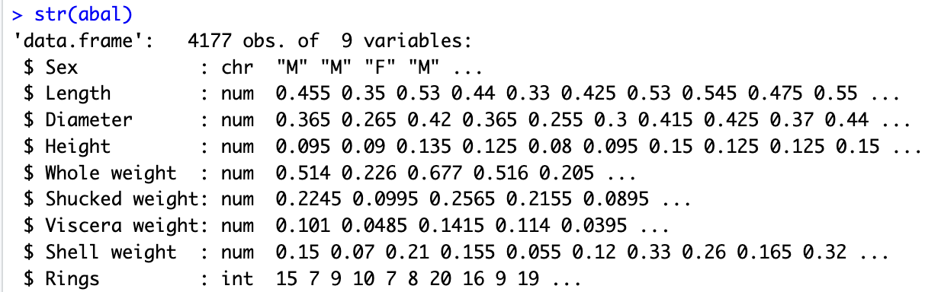

With **str()**, we can see the structure of our **abal** object. Note that the “**Sex**” attribute has the character strings type “**chr**”.

We then apply the **describe()** and **summary()** methods to get a better sense of our data.  
  
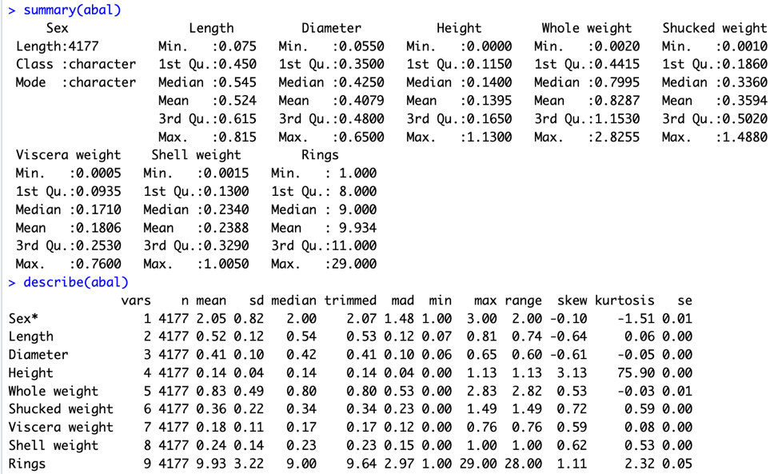

As we can see, there are no NAs in our data frame, which means we do not have to perform extra computation to account for rows with NAs in them, such as deleting those rows or replacing the NA values in a way that accounts for our analysis.

We can observe the mean value of the rings as 9.934. Additionally, the high kurtosis value of Height can be observed compared to the other attributes, indicating a heavy tailed distribution whereas the other attributes display a moderate distribution. Based on skew values, Length, Diameter, and the weight attributes indicate symmetrical distributions.

We also note that scaling is not required on our data as according to the dataset description, ranges of the continuous values have been scaled for use.

We first proceed to plot all the 9 variables in a pairwise manner.

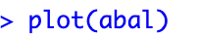

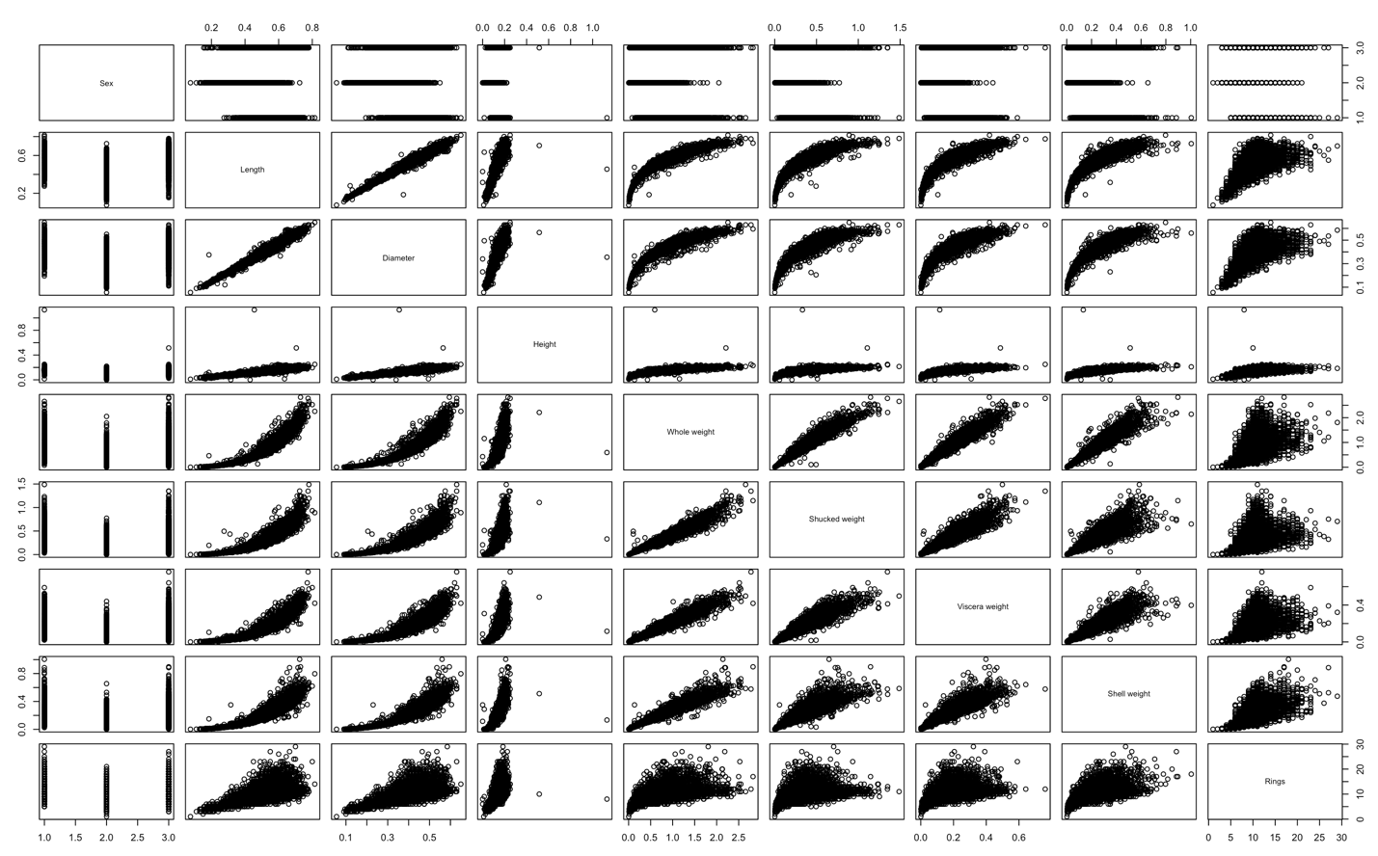

Through this plot, we observe several things. **Length** and **Diameter** have a strong linear relationship, which is to be expected, as well the linear relationships of **Whole weight**, **Shucked weight**, **Viscera weight** and **Shell Weight** with each other.

**Rings** appears to have a nonlinear relationship (possibly exponential) with the **Height**. We can also observe that **Rings** has a linear relationship with **Length** and **Diameter**, however some other attributes or other factors might be skewing this for some of the entries.

The same can be observed for **Rings vs the 4 weights**, although more outliers and fuzziness can be observed in these plots. It is also worth noting that **Sex vs other attributes** does not help us understand any sort of linear or nonlinear relationship.

In order further understand this and confirm some of the observations above, we created a 3d scatter plot with the **plotly** library: **Length** on the X-axis, **Diameter** on the Y-axis, and **Rings** on the Z-axis.

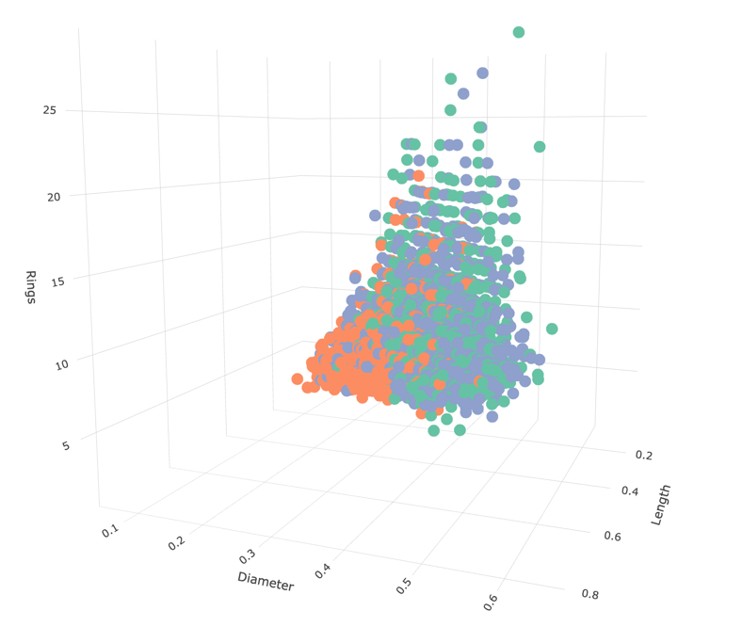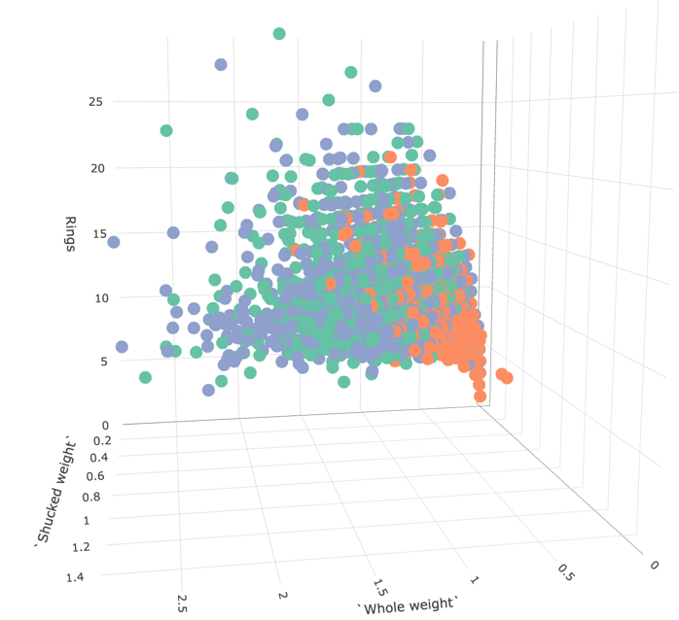

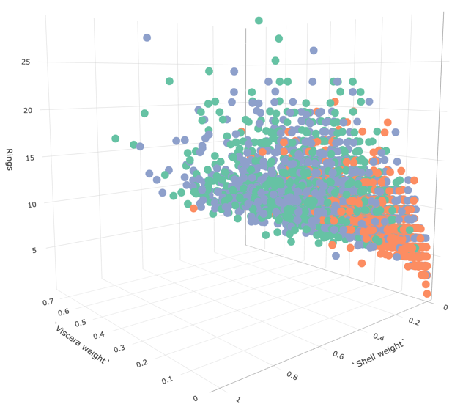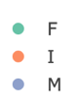

Here, we can observe again that number of Rings grows linearly with both **Length** and **Diameter**. A similar relationship is observed for the **Whole weight**, **Shucked Weight**, **Viscera Weight**, and **Shell Weight**. Another observation is that there are more infants towards the origin and as we move further up the line, the number of infants decrease, and we find more Females and Males. Intuitively, this is to be expected as Rings is a measure of age.

We wanted to further attempt to understand the relationship of Sex with the other attributes, and so we implemented **dummy encoding** to split Sex (the categorical variable) into multiple binary variables. A value of 1 in **Male** or **Female** (the other being 0) indicates the Sex, whereas a 0 in both represents **Infant**. We stored the new data frame into **abal2** and plotted the pairwise relationships again.

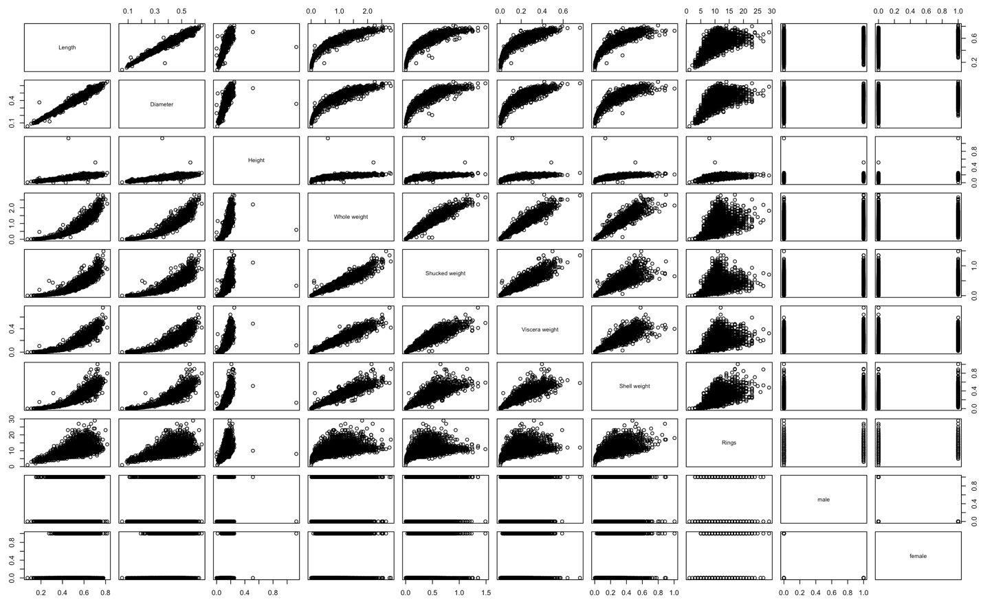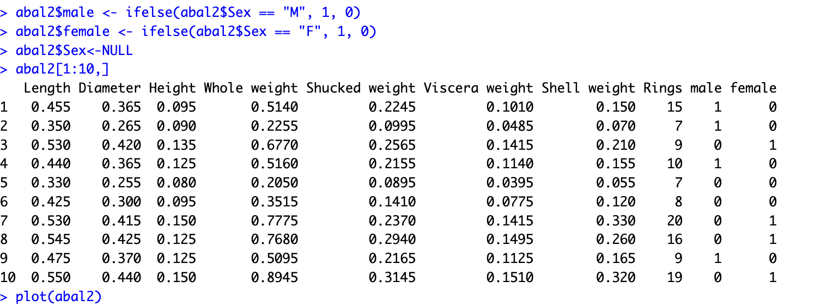

However, the new plot does not yield any new conclusions with respect to the relationship of “**Sex**” with “**Rings**” and so we decided to remove the Sex attribute from the **abal** data frame.

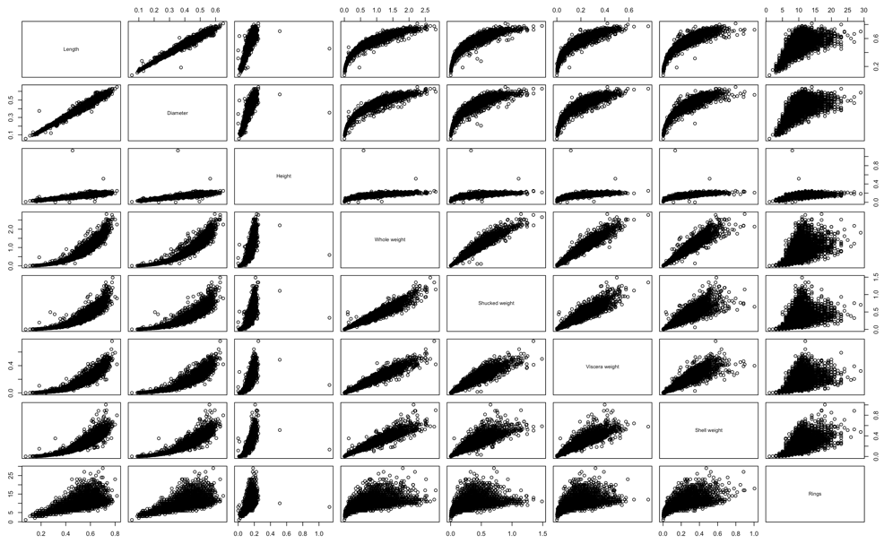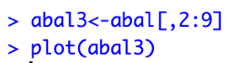

As the rubric points out, correlation matrices are a great way to understand positive and negative correlations between attributes. With the help of the **corrplot** library, we generate the correlation matrix and plot it as follows:

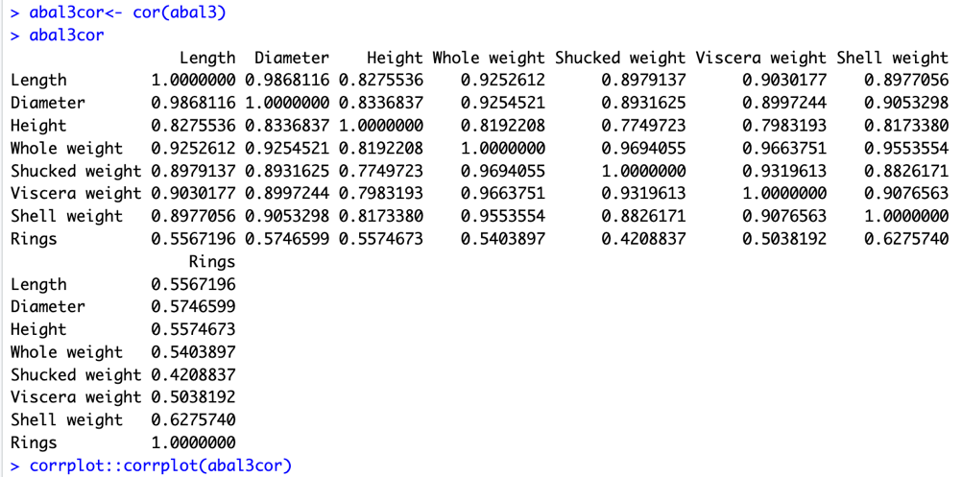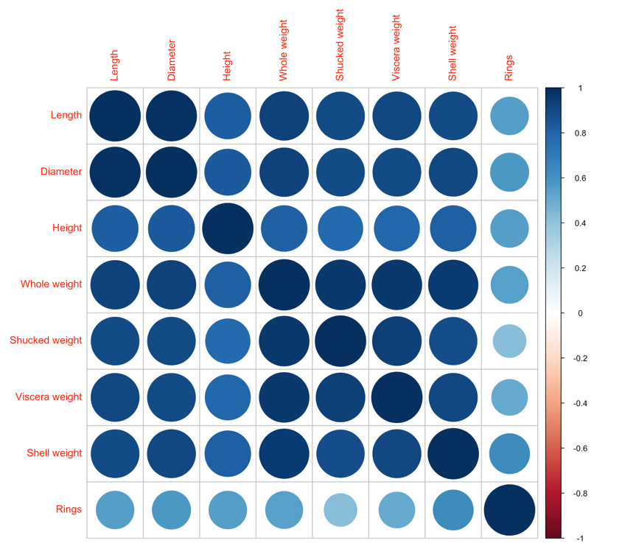

Looking at the correlation matrix, we see a weak correlation between Rings and Shucked weight, which means it is a good idea to remove Shucked Weight as an attribute. We store the new dataframe in abal6. For clustering, however, we use the whole dataset.



**3. Clustering on the Dataset (K-means)**

To perform K-means clustering on our data, we use kmeans(). We specify centers with different values to specify the number of clusters we expect. The resulting object contains the **Clustering Vector**, **Cluster means** and **between_SS /total_SS (%)** value. The collected findings for different centers are tabularized below:

 and so on.

|  |  |
| --- | --- |
| **Centers (No. of clusters to expect)** | **between_SS /total_SS (%)** |
| 2 | 56.5 |
| 3 | 77.4 |
| 4 | 84.5 |
| 5 | 85.9 |
| 6 | 91.2 |
| 7 | 93.1 |
| 8 | 92.5 |
| 9 | 93.9 |
| 10 | 95.2 |

The plots for different centers(clusters) are shown below respectively.

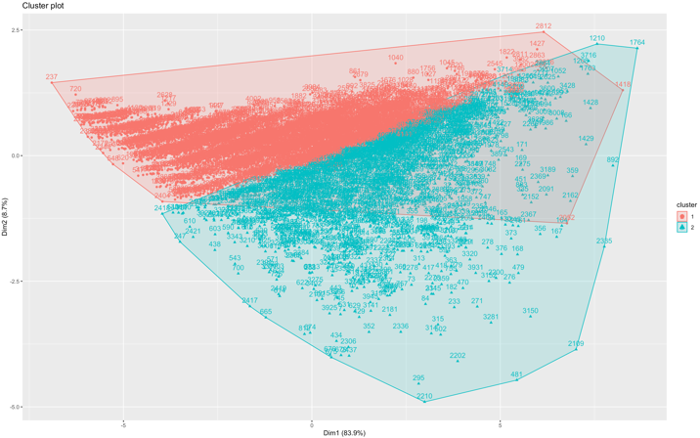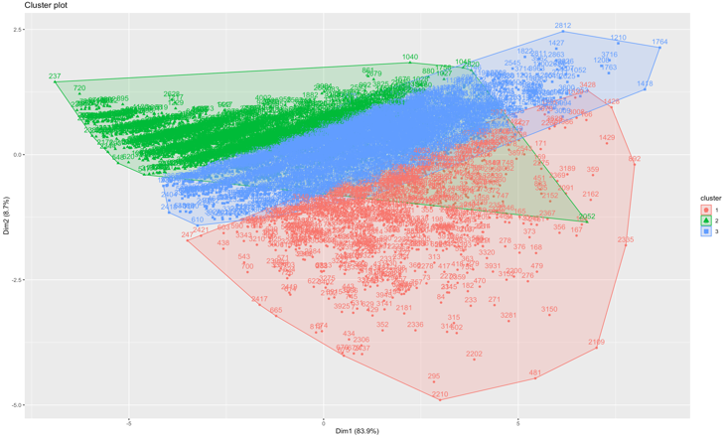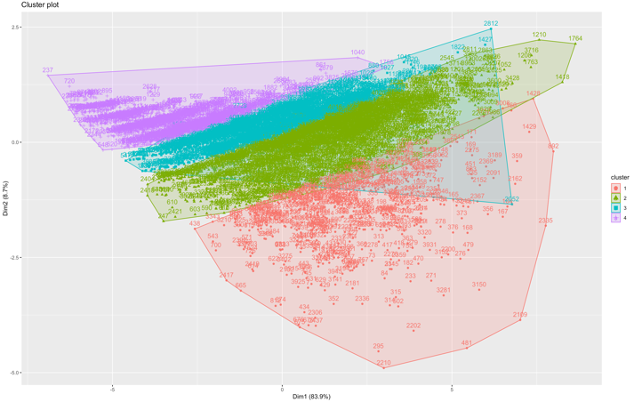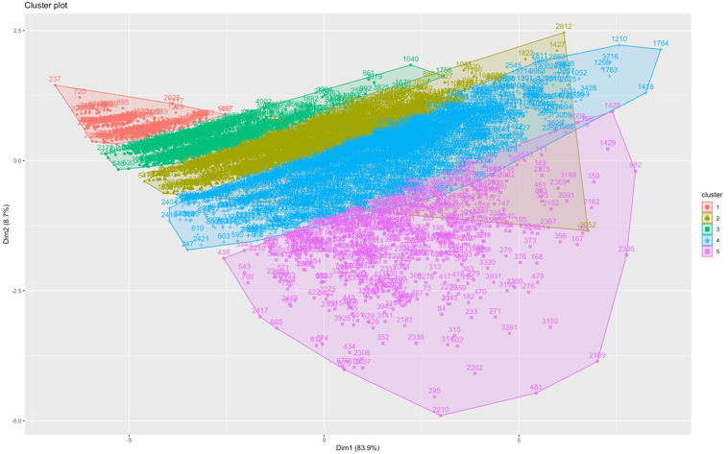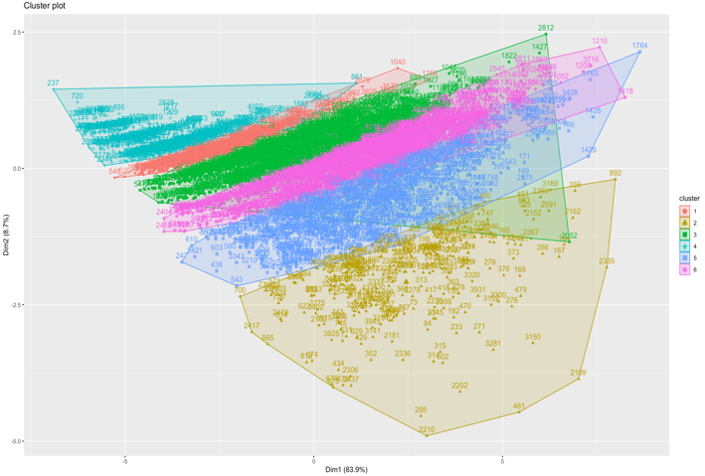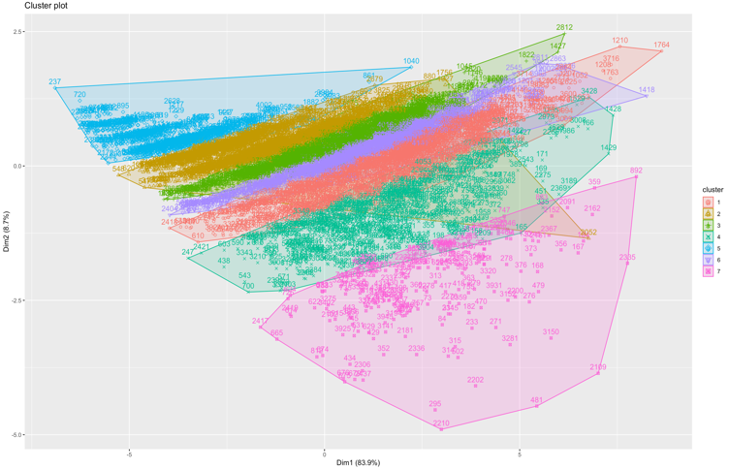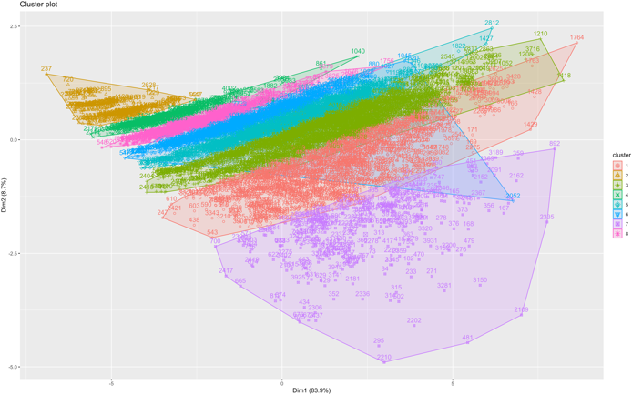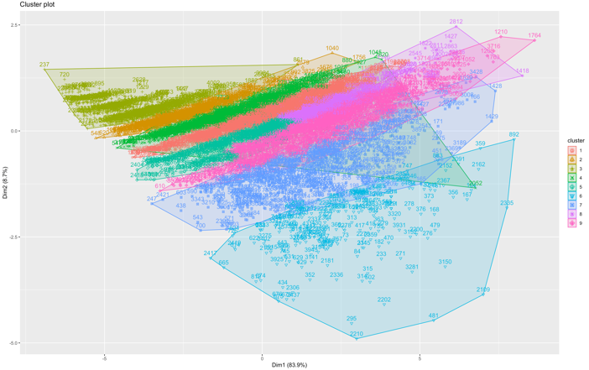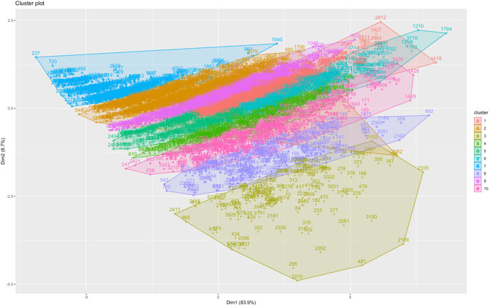

From these plots we can observe clear distinction in the data points as the number of clusters increase. However, there is also **significant overlap** which can be due to external factors that are complex and hard to capture with clustering methods. It can also be due to outliers in the data that could be distorting the clusters.

This overlap can be seen in records **3149** and **2152**-

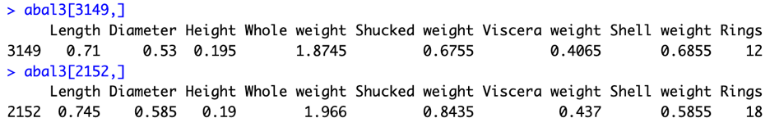

We can also observe a **homogenous distribution** of clusters from the plots above for **k=7**, which is useful as these clusters would hold strong descriptive power.



We then proceed to examine the **cluster centroids** by looking for the largest value in each column. This helps us understand the most important cluster for that attribute. From the information below, we can deduce that the most important clusters for the attributes are: **Rings-7, Shell Weight-7, Viscera Weight-7, Shucked Weight-1, Whole Weight-7, Height-7, Diameter-7, Length-7**. It is clear that the 7th cluster holds the highest importance for most attributes.

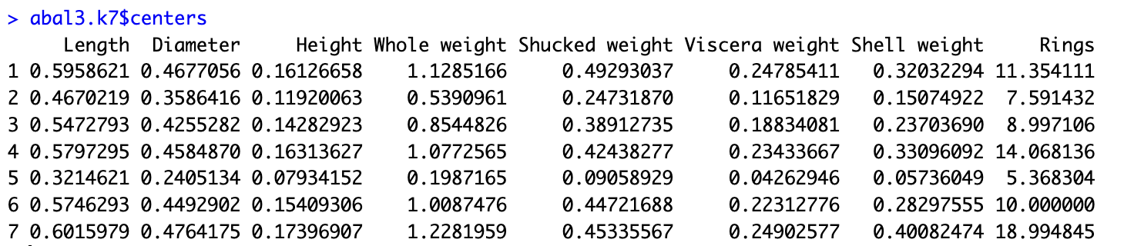

If we observe some of the records in the 7th cluster, we can see that they share “Rings” value in the range 18-21 (which is on the higher end compared to the mean of 9.934) indicating that they are some of the older specimens. The length and diameters are also on the higher end of their respective means. The weight attributes have values that vary more, but they too follow the general trend of being above their respective means to some extent.

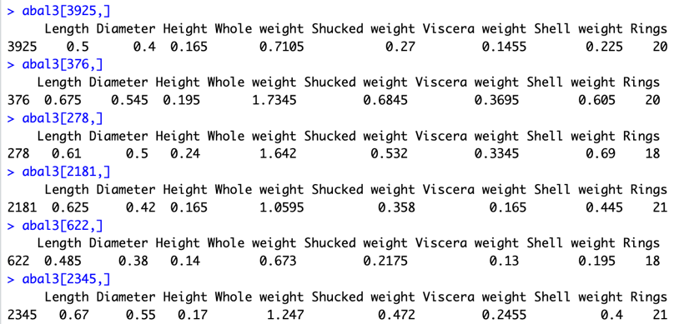

In order to find an optimal or **good number of clusters**, we can use the **wssplot** method outlined in the rubric as well as **factoextra’s fviz_nbclust()** method. The plots are shown below, **factoextra::fviz_nbclust()** and **wssplot()** respectively:

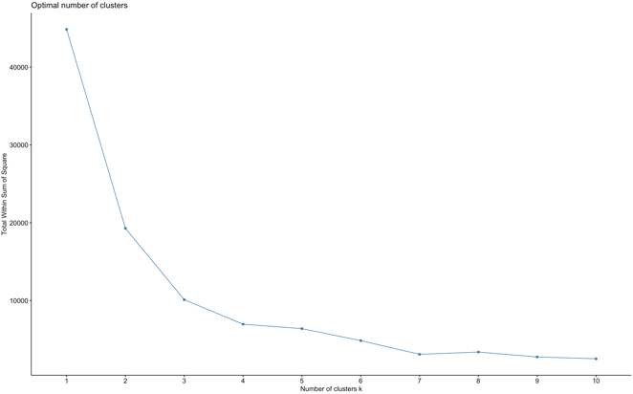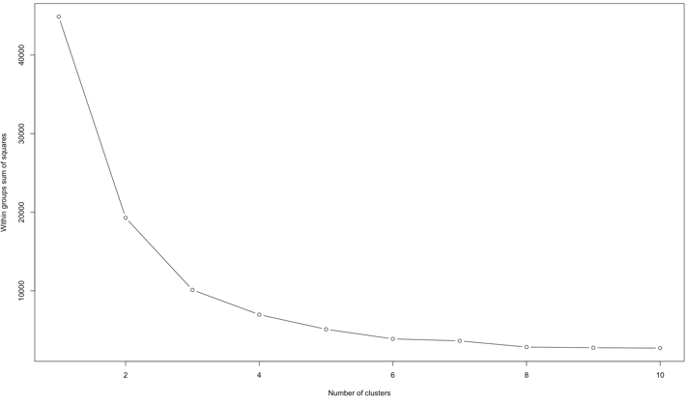

Based on the plots above, we can conclude that 6 or 7 is an optimal number of clusters.

**4. Prediction (using Training and Test Sets)**

We perform K-NN on our data, we start with creating the training and test sets.

For our analysis, we consider three cases for the training-test split: **70-30%**, **60-40%**, **50-50%**. The relevant objects to consider for these splits are **abal6**, **abal7**, and **abal8** respectively.

We start by setting the sample size to 70% and displaying the actual training records using the index. The records are in a random order.

**Note**: we use abal6 for our predictions, which is a subset of the abal data frame not including the Sex and Shucked Weight attributes.  
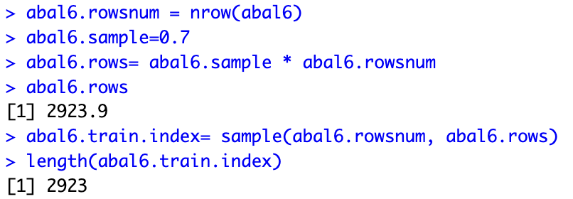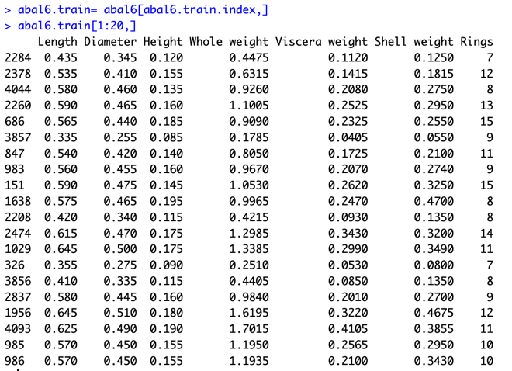  
  
Next, we construct the test data.

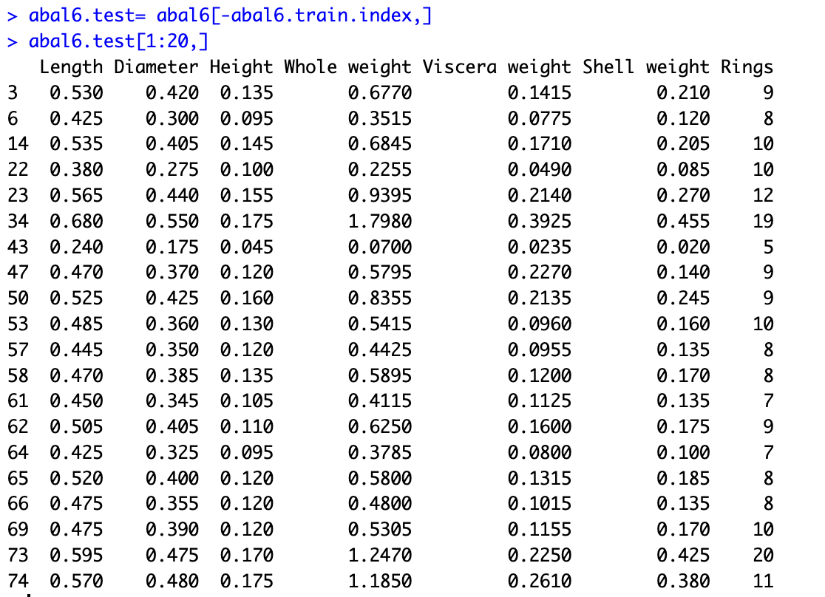

We repeat the same process for the 60-40% split and the 50-50% split.

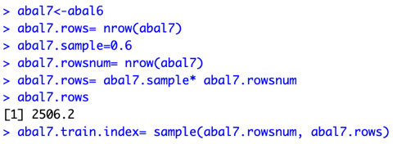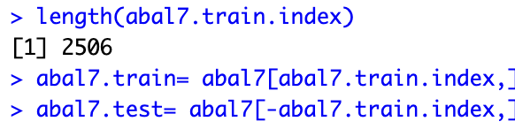

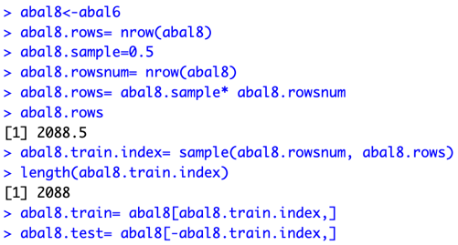

Post this, we perform K-means clustering on the training set to create training labels for kNN, keeping centers=7. Here, we have depicted only the 70-30% split but the process has been repeated for all 3 splits.

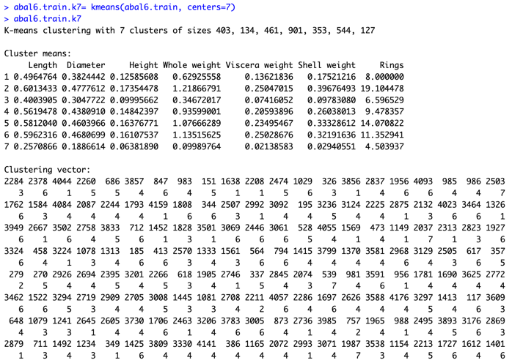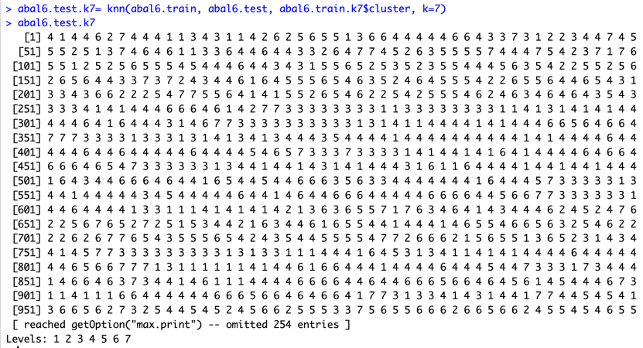

Now, we apply kNN on the test set. It returns a feature vector with the predictions for each test value. We then apply K-means to abal6.test and generate labels for the test records. These records can be found in the clustering vector.

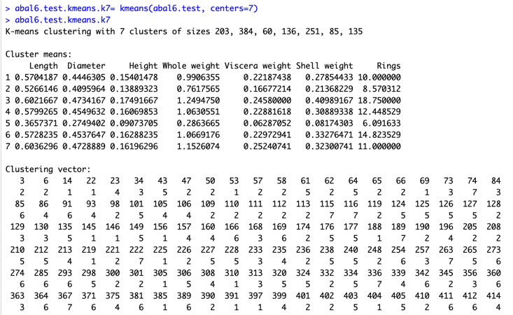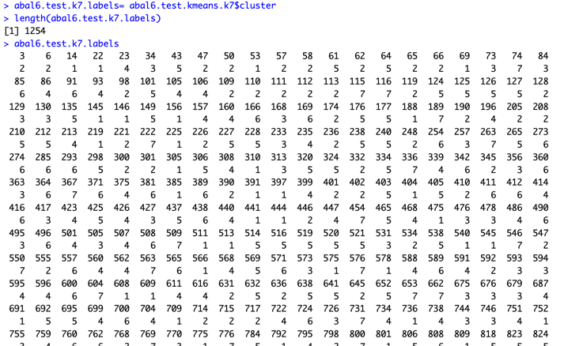  
  
We can compare the predicted values from **abal6.test.k7.labels** and **abal6.test.k7**. We can see that there is a considerable difference between them for each of the splits. This can be due to several factors (as outlined in the rubric) like the usage of different distance metrics by the two methods, and some relationships between attributes outside of our dataset, e.g., weather patterns and location (which directly affect food availability).

**5. Linear Modeling**

To proceed with linear modeling we use the glm() function from the stats package. We also applied the anova() method for analysis of variance on the model result.

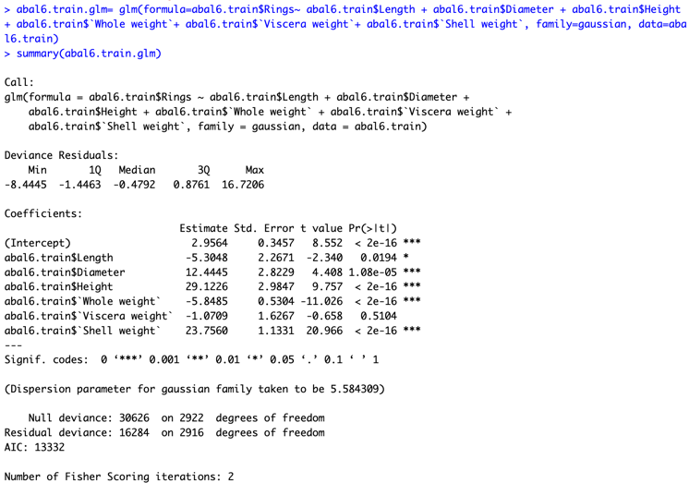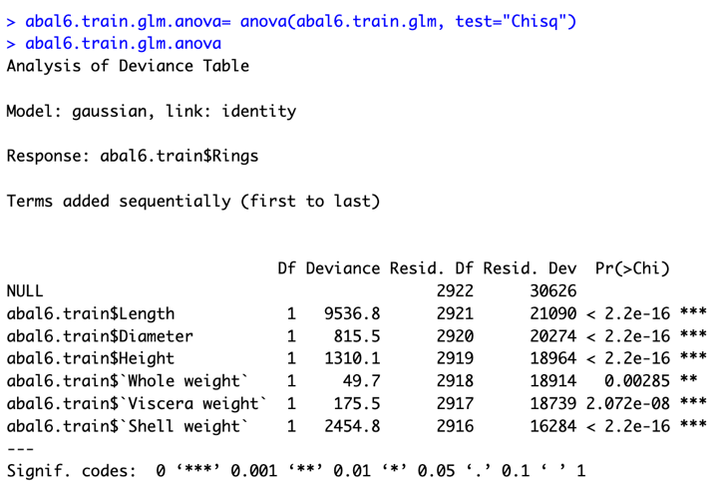

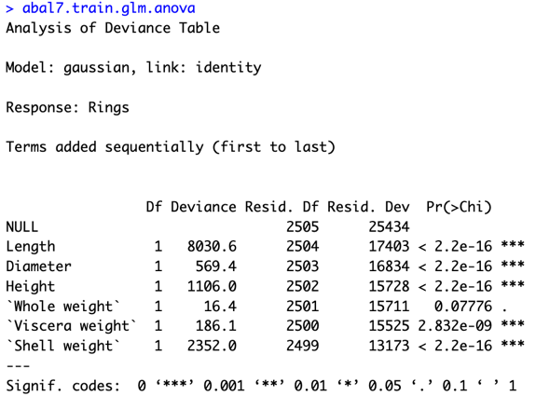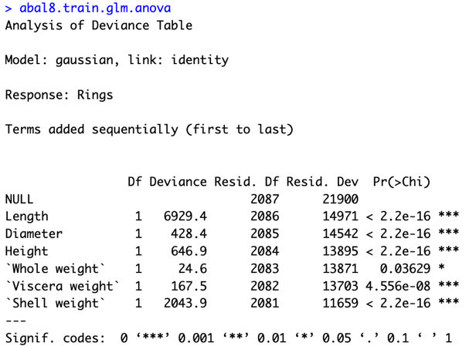

We can observe the difference between the null deviance and the residual deviance. We want this difference to be as high as possible. We can see that the deviance does not drop as we add more variables rather, it fluctuates.

Now, to plot the residual and fitted values for abal6, abal7 and abal8 respectively.

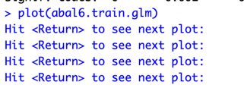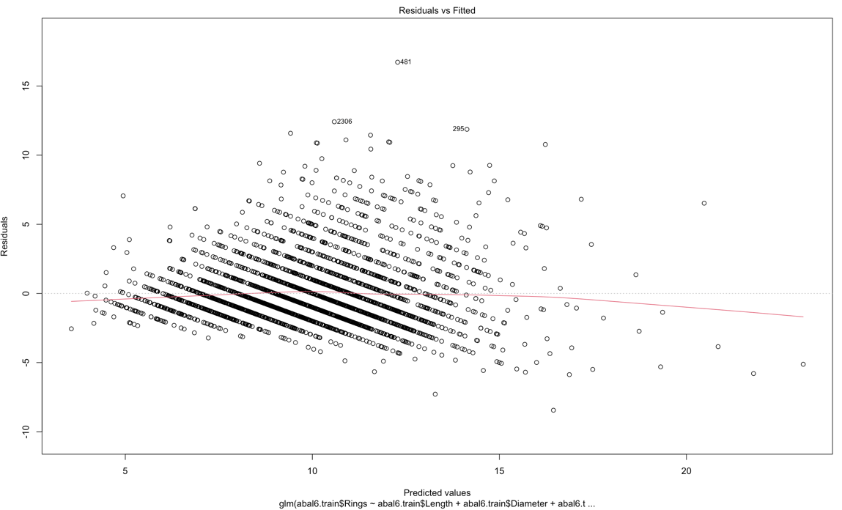

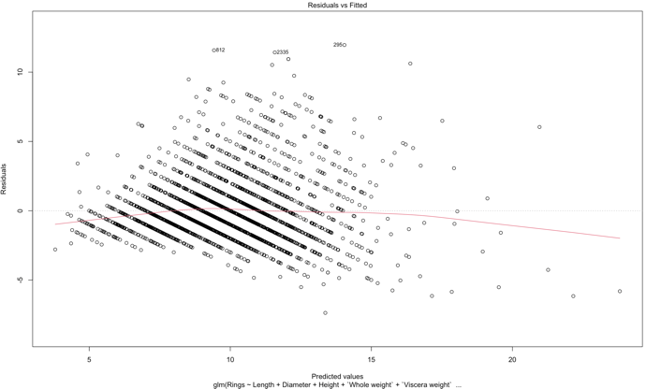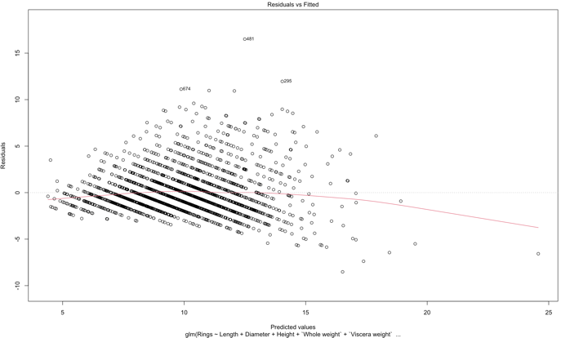

From this plot, we can clearly see a few outliers dragging the linear model down. There might be some other dependencies as well.

Shown below are the following plots: **Q-Q plot**, **Scale Location Plot** (**Spread-Location Plot**), and the **Residuals vs Leverage Plot**.

**Plots for the 70-30 split:**

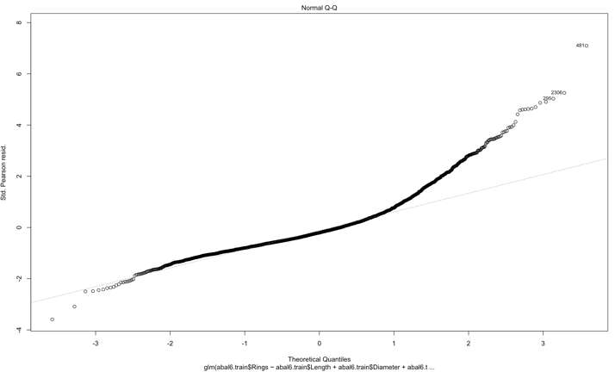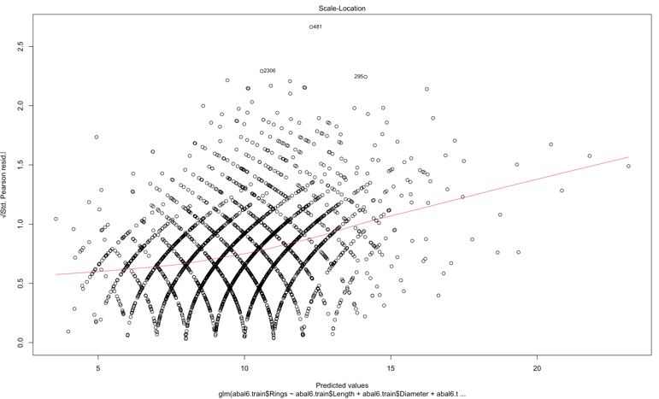 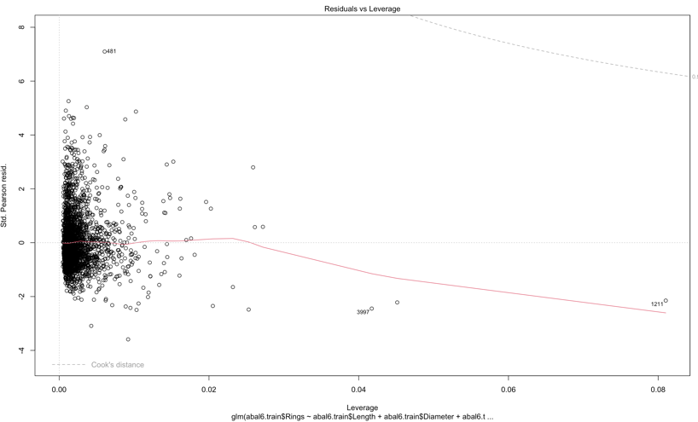

**Plots for the 60-40 split:**

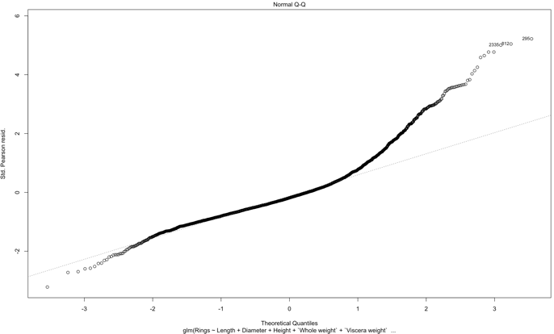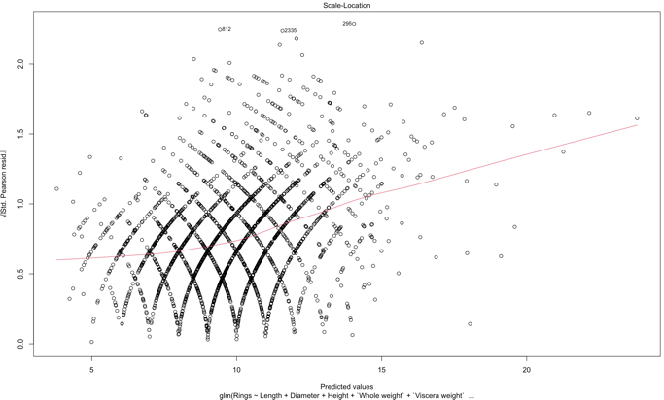

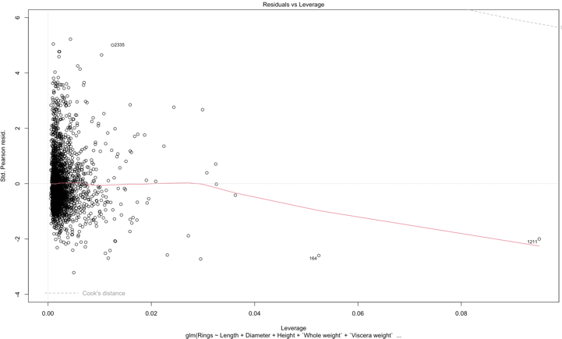

**Plots for the 50-50 split:**

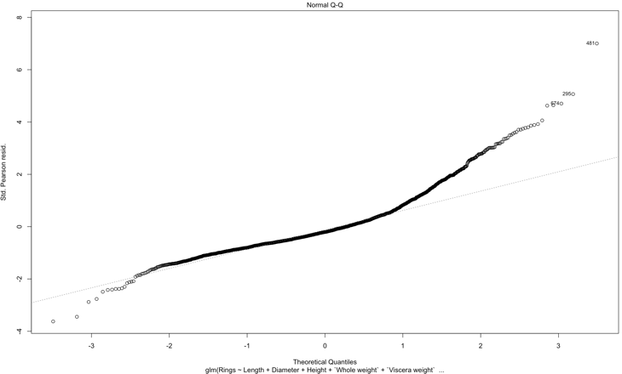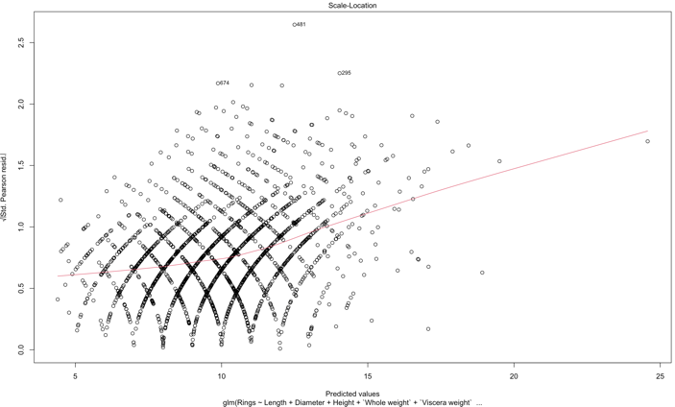

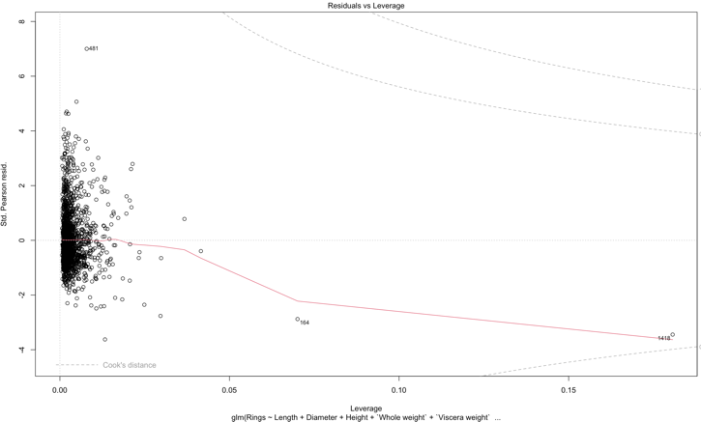

We can understand several things from these plots. From the **Q-Q plot**, it is evident that the data is normally distributed until the higher end where certain data points start dragging the curve upward.

From the **Spread Location Plot**, we can see that our line is almost horizontal and has relatively equally spread-out points.

From the **Residuals vs Leverage Plot**, which helps us find influential cases/data points. Here, we can notice that no points are outside Cook’s distance and thus not influential in affecting the regression. We can still spot outliers though.

We can now proceed to obtain **predictions**. We will be returned a vector of predicted values for Rings based on our training set.

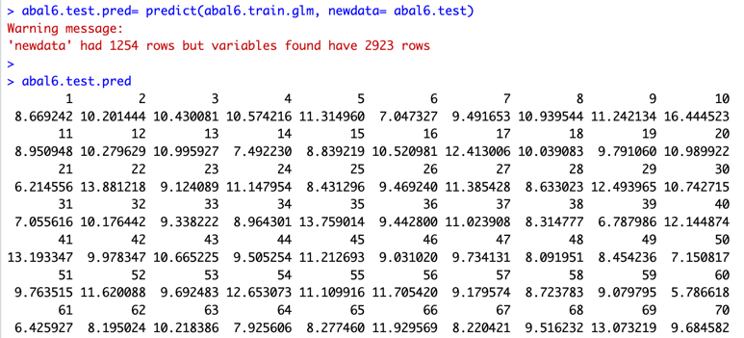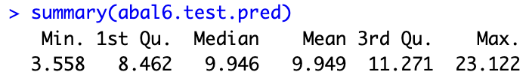

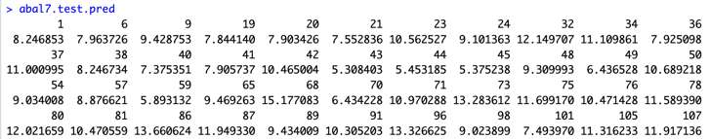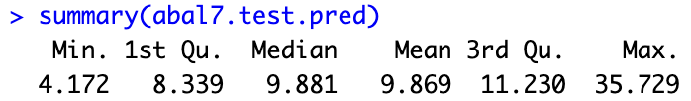

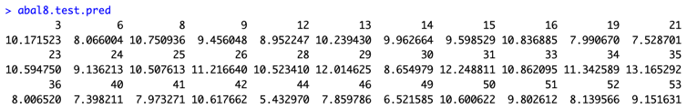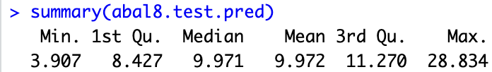

Confidence Interval:

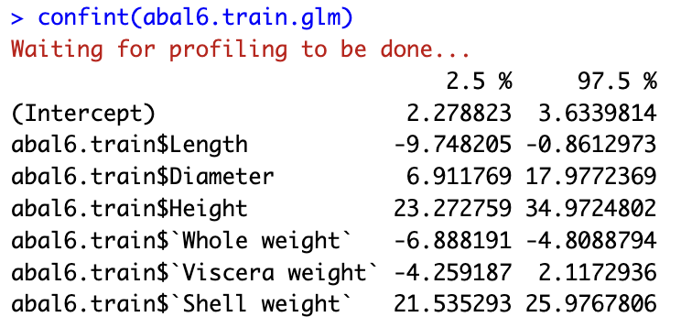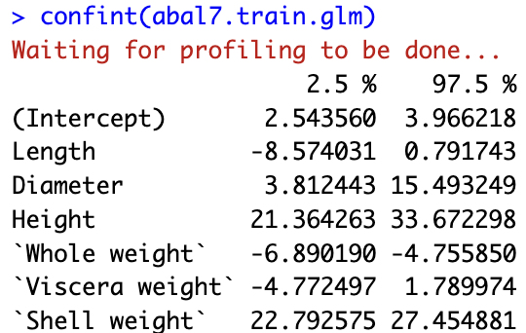

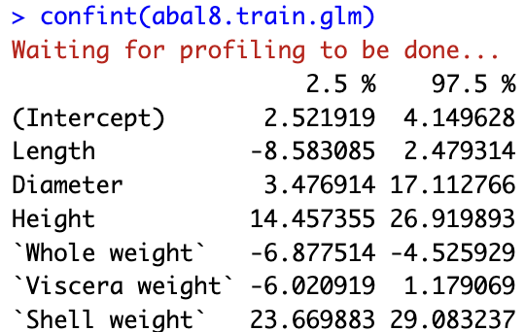

We notice the variability in the Intercept here, which is on the higher end. Other factors affecting the confidence interval include the confidence level and the sample size.

To procced for comparing actual vs predictions, we start by obtaining the K-means data for the predicted values. Post this, we compare the results from the two clusterings using the CrossTable method as shown in the rubric.

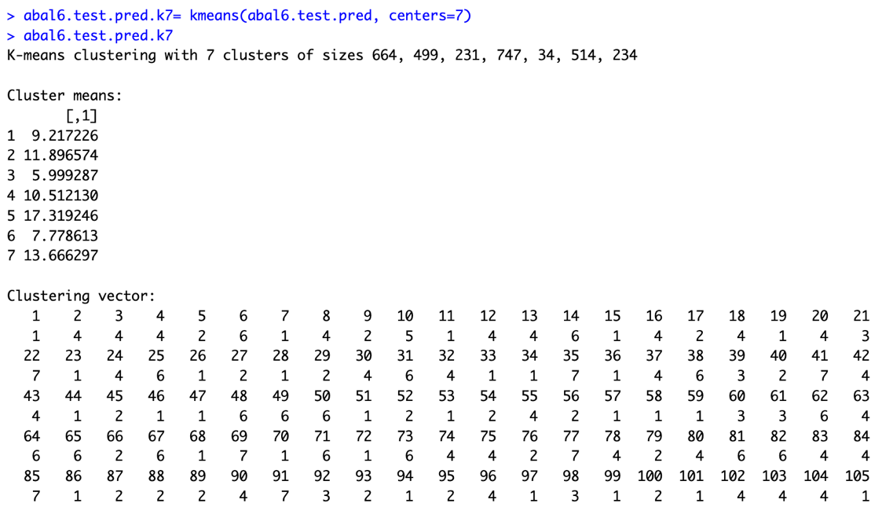

The cross tables for the three splits are shown below:

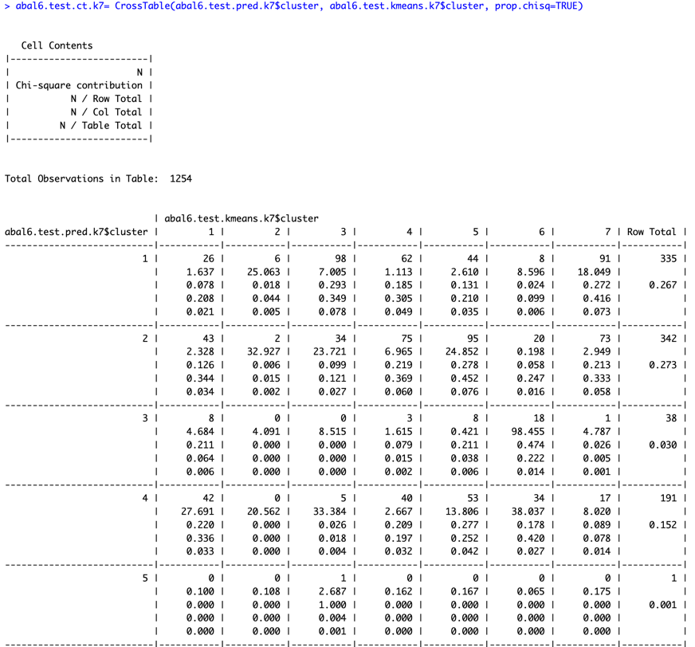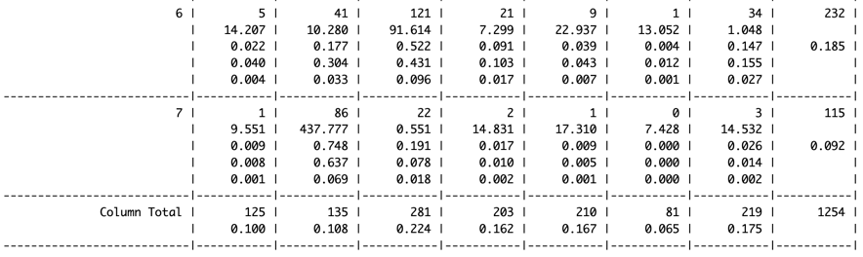

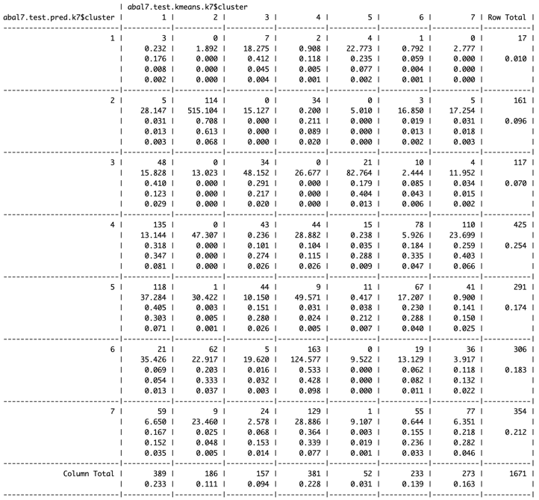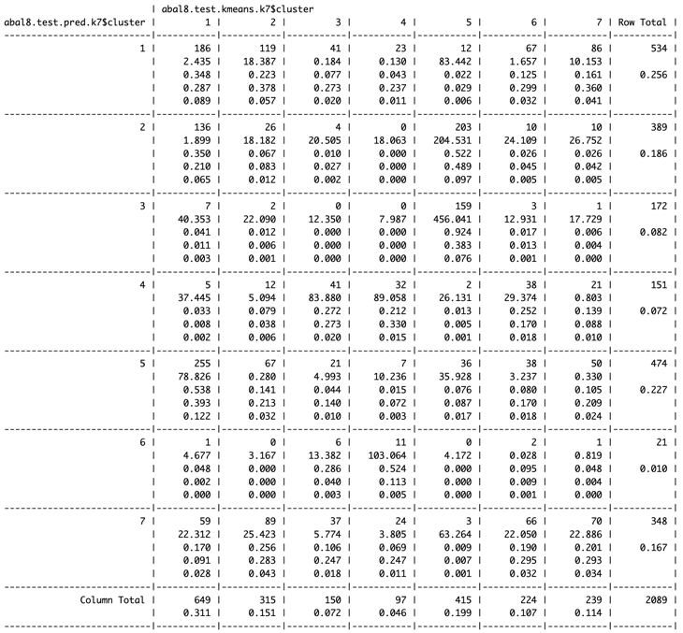

We can quickly understand just by looking at the sum of the diagonal elements of the table (where both K-means and our predictions classify the observations in the same cluster) that our predictions not classified in the same clusters as the kmeans results most of the times i.e. the predictions aren’t very good.

We plot **abal6.test$Rings** versus **abal6.test.pred** values to understand the linearity. Looking at the plots, we can understand that there is some non-linearity present (especially in the third plot), and it is not perfectly linear.

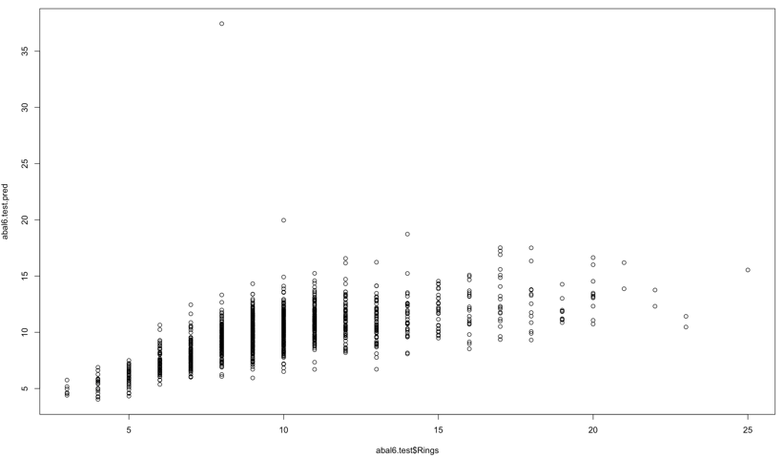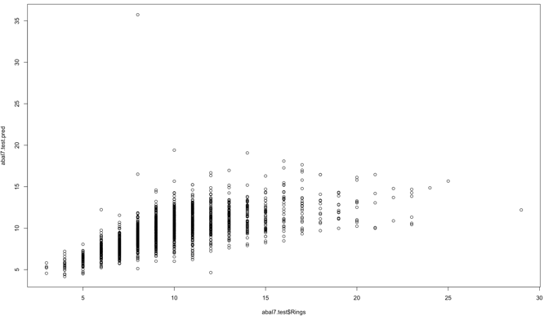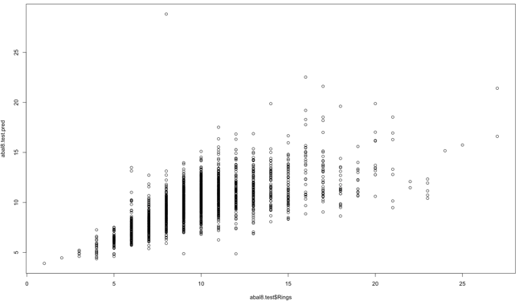

We can now look at some performance measures to further understand our results. To do this, we first compute the confusion matrix and then use it for computing our metrics as shown below.

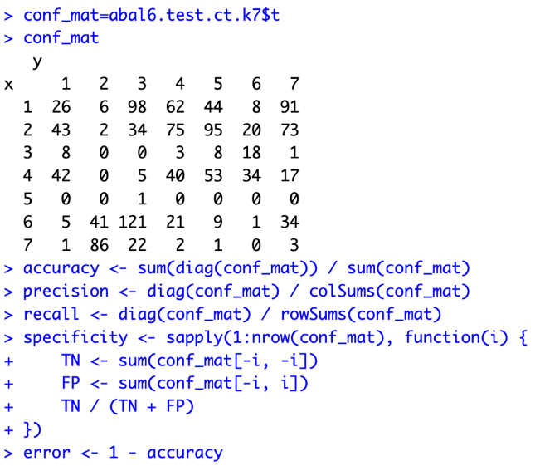

Lastly, we collected results from all the three splits and tabulated the results of the performance measures below. Since we only have True Positives and False Positives, we calculate the Precision and Error performance metrics.

|  |  |  |  |  |
| --- | --- | --- | --- | --- |
| **Split** | **Precision** | **Error** | **TP** | **FP** |
| 70-30% | 5.741627% | 94.25837% | 72 | 1182 |
| 60-40% | 18.07301% | 81.92699% | 302 | 1369 |
| 50-50% | 16.85017% | 83.14983% | 352 | 1737 |

As we can see from our results above, our precision rates are quite low. It is especially low for the 70-30 split (5.74%) and improves to 18.07% for the 60-40 split. This tells us there is further analysis that needs to be done on the attributes and maybe remove a few more in order to get better precision.